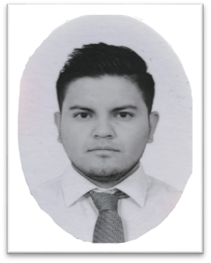
Aldo Uriel
Monroy Gómez
Ing.aldo.monroy@gmail.com


+52-55-78197055



aldomonroy.github.io/cv/
INGENIERO EN Tic´s
Tepotzotlán, edo Méx,
Méx, c.p 54600





PRESENTATION
EXPERIENCE
Tic Engineer with 2 years of experience in the area of technical support and web development.
I seek to generate experience in the area of networks and infrastructure, I have knowledge of electronics, programming languages, basic knowledge of servers, great persuasion and leadership skills.
My goal is to be an international class Tic engineer, focused on infrastructure.
Currently I continue to train with courses and certifications to achieve my goal in the shortest possible time.
Corporativo Inmobiliario / Nov 2019 - Current

Technical support – Digital mkt
Development and implementation of the website, brand, social networks, network installation, printer and machine configuration, user support.

Klassco Company / Jan 2019 - Nov 2019
Business Process and Technology Intern

Process mapping, project implementation for the automation of steps in the supply chain process, optimizing time and costs.

Support / JAN 2018 - DEC 2019

Technician in repair
Profesional Skills

Software and hardware repair of smartphones, computers and drones.
Installation of programs, formatting, maintenance.
Web design

HTML5,C,JS

schooling
Office


Technical support

Ing at Tic´s / Dec 2015 - Current
Process mapping
Networks and programming
UMB Tepotzotlán


Ing Industrial / ENE 2015 – incomplete
TESCI
Mechatronics technician / ENE 2012 – Ene 2015
CBT Gabriel V. Alcocer
Leadership
SOFT SKILLS
Persuasion
communication
seller
Empathy
Languages
Native Spanish
English – B2

